**Academic Year: 2024-25 Semester: V Class / Branch: TE IT**

**Subject: DevOPs Lab (DL)**

**Subject Lab In-charge: Prof. Sujata Oak**

**EXPERIMENT NO.12**

**Aim: Deploy a website code on the node by provisioning mysql server and database using ansible playbook.**

**Theory:** MySQL Database is a client/server system that consists of a multithreaded SQL server that supports different back ends, several different client programs and libraries, administrative tools, and a wide range of application-programming interfaces (APIs).

**Primary Terminologies**

* **MySQL:** For the storage and management of structured data, a lot of people use MySQL, an open-source relational database management system (RDBMS). It offers components, for instance, SQL support, data security, versatility, and execution.
* **Ansible** is a configuration management tool. it is a suit of software tools that enables infrastructure as code.it is an open source and suit includes software provisioning, configuration management and application deployment functionality. There is no need to install run time, as it is a stand-alone tool.
* **Ansible Playbooks-** playbooks are the basis for really a simple configuration management and multi-machine deployment system. [Ansible playbooks](https://www.geeksforgeeks.org/ansible/) are YAML documents containing a set of instructions for Ansible to execute on remote hosts. Playbooks automate tasks like software installation, service configuration, and file management by defining the desired state of systems.
* **Modules for Ansible-** [Ansible](https://www.geeksforgeeks.org/ansible/)modules are little projects that perform tasks on remote hosts. For common tasks like package management, file manipulation, and service control, Ansible has a lot of built-in modules. The Ansible engine runs modules on the target hosts and sends back the results to the control node.

**STEP1:**

**Ansible-master:**

**root@ip-172-31-18-177:~/ansible-lab/ansible-codes# nano mysqlmodule.yml**



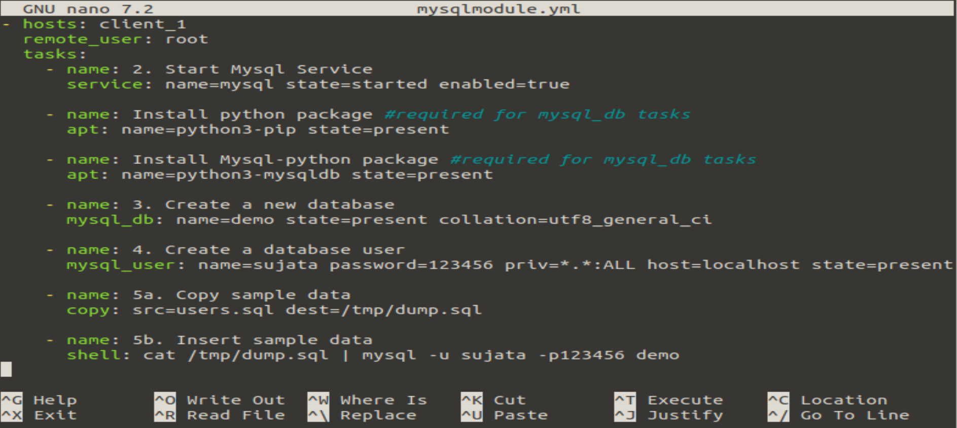

**root@ip-172-31-18-177:~/ansible-lab/ansible-codes# cat users.sql**

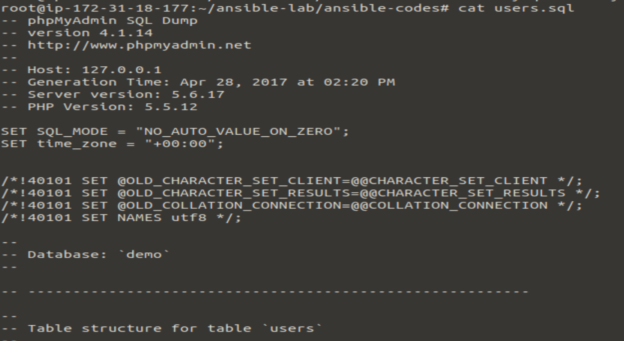

**STEP2:**

**root@ip-172-31-18-177:~/ansible-lab/ansible-codes# ansible-playbook mysqlmodule.yml**

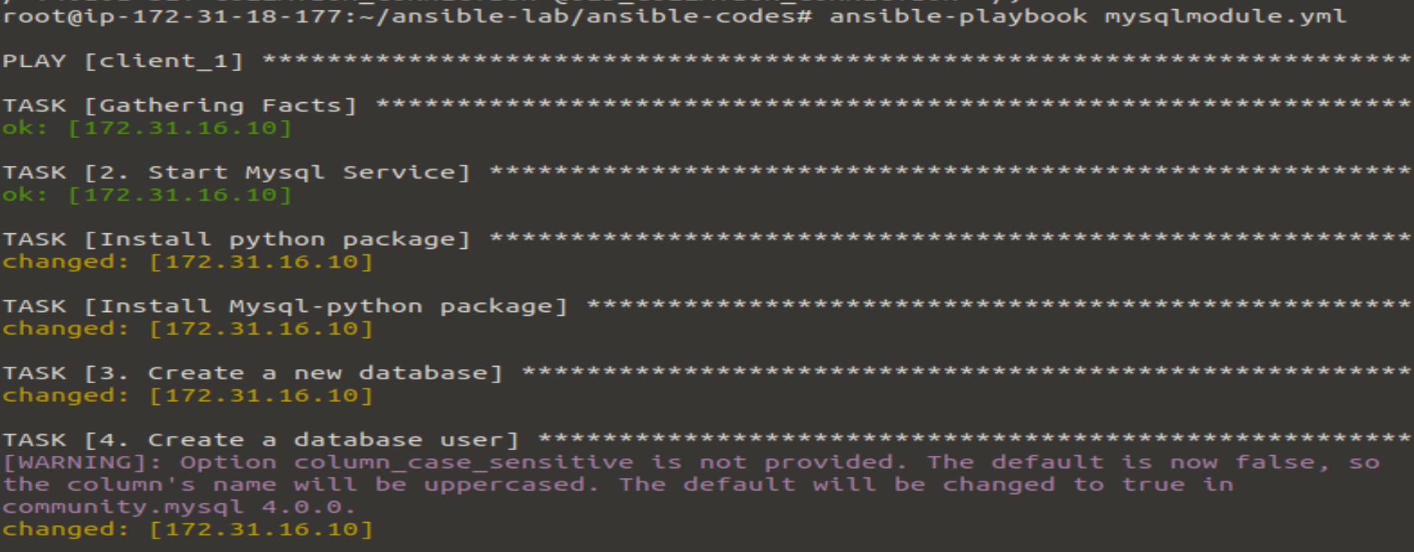

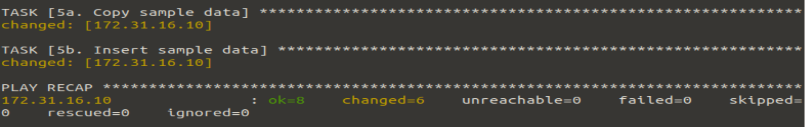

**STEP3: ansible-slave**

**root@ip-172-31-16-10:~# mysql -u sujata -p123456**

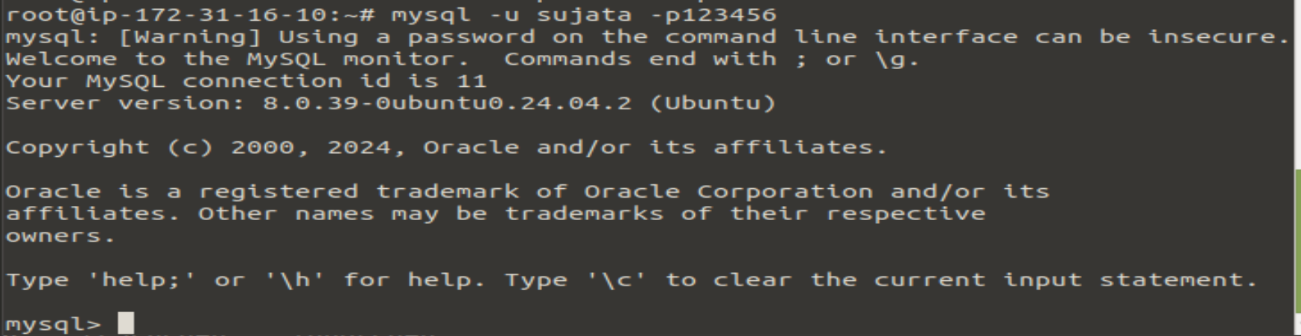

**mysql> show databases;**

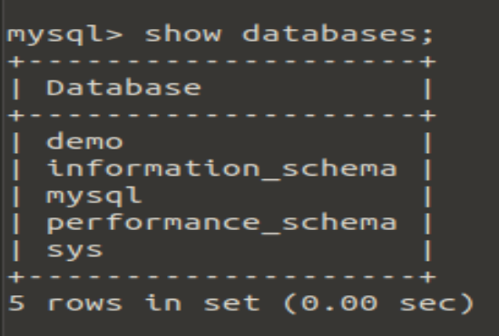

**mysql> use mysql;**

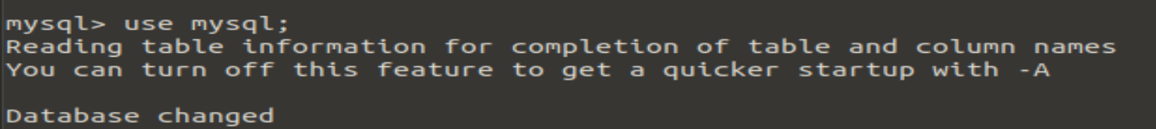

**mysql> show tables;**

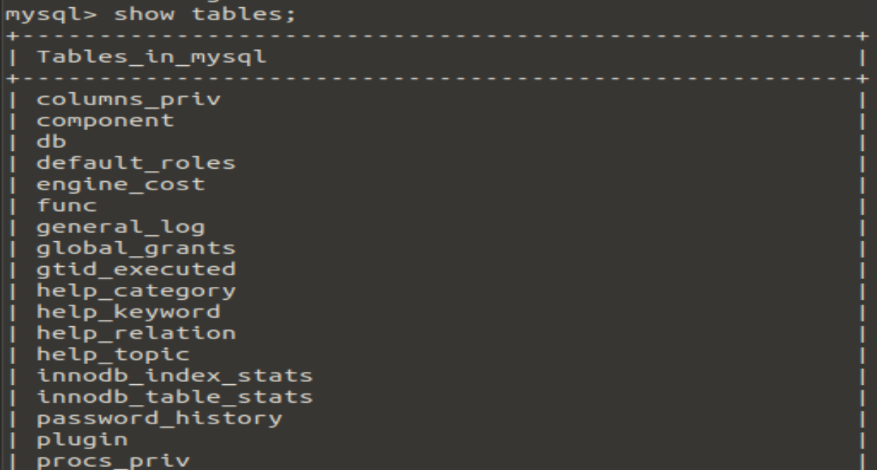

**mysql> select * from db;**

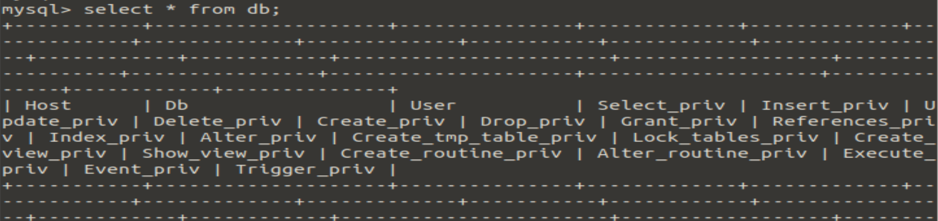

**mysql> exit**

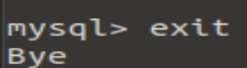

**STEP4: ansible-master**

**root@ip-172-31-18-177:~/ansible-lab/ansible-codes# nano deploywebsite.yml**

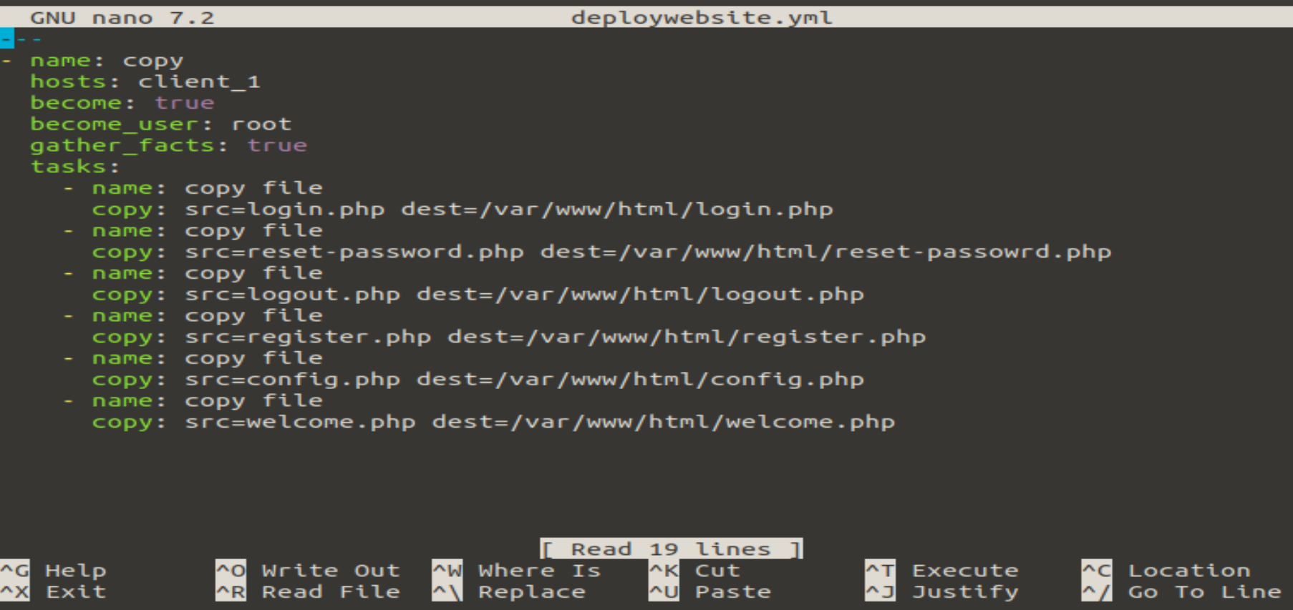

**root@ip-172-31-18-177:~/ansible-lab/ansible-codes# ansible-playbook deploywebsite.yml**

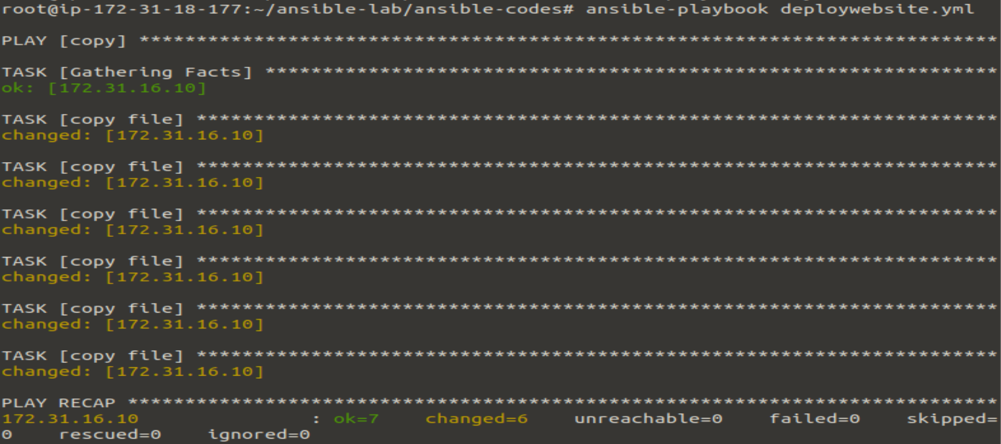

**Ansible-slave:**

**root@ip-172-31-16-10:~# cd /var/www/html**

**root@ip-172-31-16-10:/var/www/html# ls**

config.php login.php register.php welcome.php

index.html logout.php reset-passowrd.php

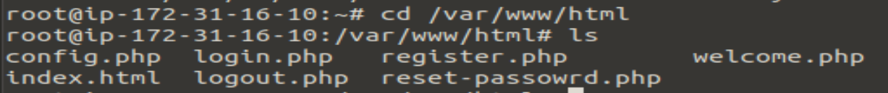

**STEP5: Goto Browser: ansible-slave machine IP address/login.php**

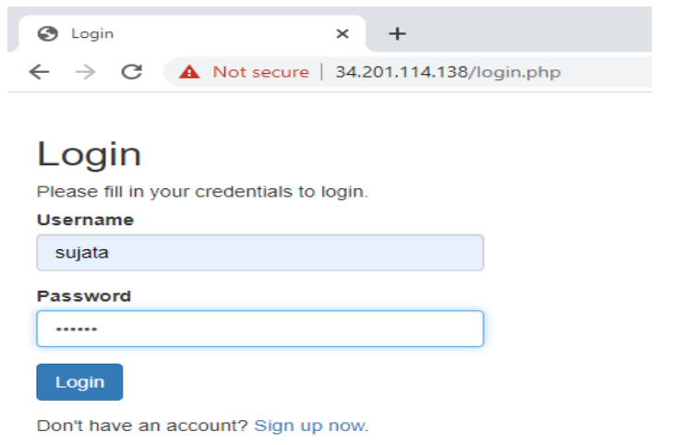

**IP address/welcome.php**

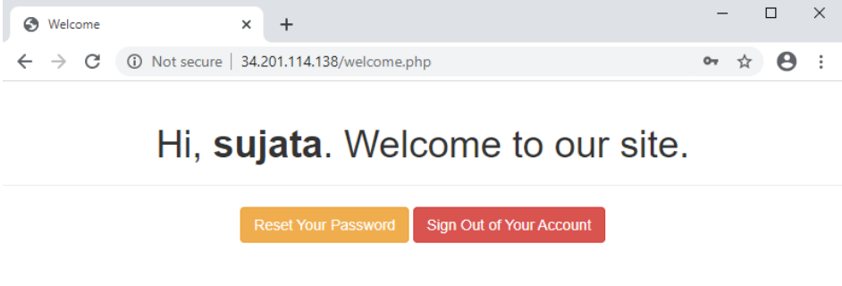

**IP address/reset-password.php**

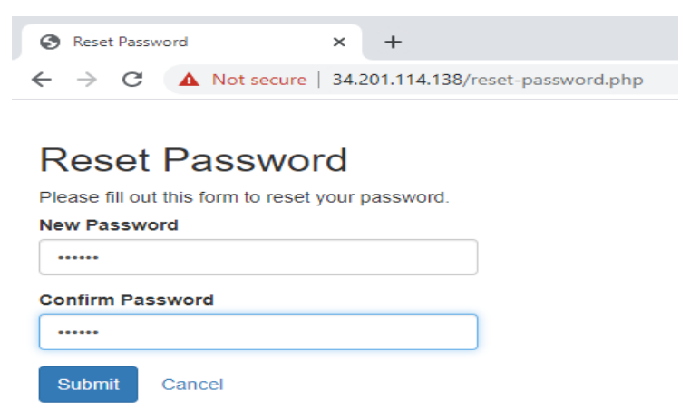

**Conclusion:** In the experiment, we successfully deploy a website code on the node by provisioning mysql server and database using ansible playbook.